***A Mini Project Report on***

**FINANCIAL CORPORATION SITE USING KYC SYSTEM**

**T. E. Computer Engineering-A**

**Submitted By**

**Agnellus Fernandes 36**

**Anisha Fernandes 37**

**Chelsea Fernandes 38**

**Under the Guidance Of**

**Jayshree Mittal**



ST. FRANCIS INSTITUTE OF TECHNOLOGY

(ENGINEERING COLLEGE)

Mount Poinsur S.V.P Road, Borivali (W), Mumbai-400103

UNIVERSITY OF MUMBAI

2019-2020

**CERTIFICATE**

This to certify that the Mini Project report on '**Financial Corporation Site Using Kyc System**' has been carried out by **Agnellus Fernandes**(TE/CMPN/36), **Anisha Fernandes**(TE/CMPN/37), **Chelsea Fernandes**(TE/CMPN/38) who are bona fide students of St. Francis Institute of Technology, Mumbai in partial fulfillment of the requirement of T. E. degree in Computer Engineering at St. Francis Institute of Technology, Mumbai, India. It is also certified that this work has not been presented anywhere else for award of any other degree or diploma prior to this.

**Project In-charge:**

**Jayshree Mittal**

**Internal Examiner External Examiner**

**_________________________ __________________________**

**( ) ( )**

**Acknowledgements**

We would like to thank Ms. Jayshree Mittal, our course coordinator, for her valuable guidance, timely suggestions and constant encouragement, assessment that provided inspiration and help in fulfilment of this mini project.

This mini project is a result of cooperation, hard work and good wishes of many well-wishers.

**TABLE OF CONTENTS**

1. Introduction 5

1.1 Project Objective 5

1.2 Features Of The System 5

2. System Requirements Specification 6

2.1 Software Requirements Specification (Srs) 6

2.2 User Interface Specification 7

2.3 Database Requirements 7

2.4 Functional Requirements 8

2.5 Nonfunctional Requirements 8

2.6 Business Process Of The System 8

3. System Environment 10

3.1 Hardware 10

3.2 Software 10

4. System Design 11

4.1 Input Design 11

4.2 Output Design 11

4.3 Database Design 12

5. Conclusion And Future Scope 12

6. Screenshots 13

7. References 19

# 1. INTRODUCTION

# 1.1 Project Objective

The financial service website using kyc system provides the user with facilities of accessing verified property estate, business opportunity of posting property and insurance services through kyc.

A kyc system also known as “know your customer” is a process to identify the customers details and financial risks ensuring bank details are not misused. The kyc verification for customer’s made compulsory so that the bank can have all the details of their customer and the customer can also access other financial features.

The purpose of the financial cooperation website is to allow the customers to access the features of insurance and verified property estate through a kyc form by the help of computerized equipment and full-fledged computer software, fulfilling their requirements, so that their valuable data/ information can be stored for a longer period of time with easy accessing and manipulation of the same

The main object of the project is to verify its users so that the other important aspects like insurance, buying, selling and renting are not misused the project is built at administrative end and thus only the admin is guaranteed the access. The user can fill the kyc form and verify himself to apply insurance and also gives a business opportunity to post his property to other users. Other verified users who are interested to buy or rent a property are also assured that the property is verified

# 1.2 Features of the System

The system will be performing the following tasks:

* The system will provide an interface to the user for register and login.
* The user will have access to features like kyc, insurance and real estate
* On filling the kyc form the kyc number will be generated and can be used to access the other features
* Admin can view and verify all the details of kyc.
* The admin can update the information related to occupation, address and

contact information.

the user can post his property which is verified by kyc number.

* Other users can view the property according to their budget
* Users can also apply for insurance and calculate the premium insurance.

# 2. SYSTEM REQUIREMENTS SPECIFICATION

# 2.1 Software Requirements Specification (SRS)

The specific features of SRS include:

* Establishing the basis for an agreement between the client and the developer.
* Producing a reference for validation of the final product. SRS assist clients in determining if the software meets the requirements.

The basic software required for our project was the XAMPP server. The XAMPP server with the features of apache server and MySQL database helped in designing efficient databases with relational constraints. The apache and MySQL have to be in start state. The other requirement is a web browser.

# 2.2 User Interface Specification

The user of the proposed system requires that the developed software should be user friendly, have security success and ensure the privacy of the user and produce results in timely manner. The web pages must be user friendly and must be in an easy-to-use style. The user must be able to switch easily among various screens. The user interface should be as attractive as possible. The system must provide reliable and up-to-date information.

Our website provides a user friendly and secured kyc system, where the user entered information is verified. The user can easily post about his property details so that other users can easily view them. This provides a interface for users to interact and see the property posted by other users. The insurance system in our project allows the user to select a efficient premium plan.

# 2.3 Database Requirements

The database should be designed in such a way that it enhances the efficient marketing and manipulation of all the information associated. For instance, all general information regarding the customer kyc details, the images posted, insurance etc. Should be stored in the form of tables in the database. The database should be organized in such a way that it helps in searching and updating various essential summaries needed for users.

The MySQL database is imported from the XAMPP server. The database in our project is secured and centralized. Only the admin can access the user’s details and update them. Our database provides an efficient storage of all the details of the property, customers address and other details which can be retrieved. The join SQL queries are used for efficient retrieval of information.

# 2.4 Functional Requirements

The various functional requirements of the system can be summarized as: -

(a) A home page that is user friendly and unambiguous.

(b) It is easy to register and login for a user.

(c) User can easily enter all the personal details like pan number, Aadhar number, account id.

(d) User is secured to access the insurance features online.

(e) User is assured that the property posted by other users are verified.

(f) Admin can view all the kyc information easily.

(g) The admin can also update the information of users.

# 2.5 Nonfunctional Requirements

Non-functional requirements define the system properties and constraints that arise through user need because of the budgeted constraints or organizational policies, or because of the need for interoperability with other software or due to the external factors such as safety regulations, privacy registrations and so on.

# 2.6 Business Process of the System

**Customer side:**

When a customer visits our financial corporation site he is prompted to register and log in to access any features of the website such as insurance and property. After customer logs in he can access features of the site. A feature called kyc form is made available on homepage after login. Whenever a customer fills kyc form, all his details like name, occupation, bank acc no, account type, pan number, etc. goes into kyc database and customer is given a unique kyc number which is generation using “rand ()” function in php. After this if customer wants to view about insurance details, he is free to view. But as soon as a customer wants to buy an insurance, he is prompted to enter kyc number to proceed with payment. If a customer doesn’t have a kyc, he can choose “don’t have a kyc? Do it here” option which will direct him to first page for filling the form. Similarly, in property section, a customer can view listed properties which are there in property database. A customer can also upload about his property rent or buy option, by uploading necessary information like location, price, sq. ft etc. But if a kyc verified customer uploads a property a verified badge will be seen beside that upload of property. So, by doing this, we make sure that all customers are kyc verified, which means all their necessary details are verified and they can proceed to take insurance and upload verified customer property.

**Insert query on kyc_account :**

Insert into `kyc_account`(`bank_no`, `preffix`, `firstname`, `lastname`, `pan_no`, `adhar_no`, `home_name`, `area`, `land_mark`, `town`, `city`, `country`, `occupation`, `kyc_no`) values ([value-1],[value-2],[value-3],[value-4],[value-5],[value-6],[value-7],[value-8],[value-9],[value-10],[value-11],[value-12],[value-13],[value-14])

**Primary key foreign key constraints:**

Alter table `bank_account` add foreign key (`kyc_no`) references `kyc_account`(`kyc_no`) on delete restrict on update restrict;

**Admin side:**

In admin side, admin has to log in to add a customer into kyc database by filling kyc form, all his details like name, occupation, bank acc no, account type, pan number, etc. goes into kyc database and customer is given a unique kyc number which is generation using “rand()” function in php. After this the admin of kyc system can view details of all customers in kyc database. Another feature which admin has is updating specific values, joins are been used for this, in kyc_acc table. Thus, through all these features admin can have huge control over kyc database and can monitor it thoroughly.

# 3. SYSTEM ENVIRONMENT

# 3.1 Hardware

The hardware environment consists of the following:

CPU: Processor: Intel(R) Core (TM) i7-6600U

Mother board: 80FD KBC Version 22.73

Hard disk space: 20 GB and above

Display: 15” Monitor and 720p resolution

Memory: 128 MB

Other devices: Mouse and Keyboard

# 3.2 Software

technically the system will run on any OS having web browser.

(a) development tools:

Front end: html, CSS, JavaScript.

Back end: MySQL.

Languages: html, php, ajax, jQuery.

(b) operating system: windows 10.

(c) web browser: google chrome, internet explorer.

(d) web server: web server (XAMPP).

# 4. SYSTEM DESIGN

# 4.1 Input design

Input design is the link that ties the information system into the world of its users. The input design involves determining what the inputs are, how to validate the data, how to minimize the data entry and how to provide a multi-user facility. Input design is the process of converting user-originated inputs to a computer-based format. Input data are collected and organized into groups of similar data. Once identified, the appropriate input media are selected for processing. All the input data are validated in the order and of any data violates any conditions, the user is warned by a message. If the data satisfies all the conditions then it is transferred to the appropriate tables in the database.

In our project there is validation of users and admins separately. the user has to register only then he can access the website’s other features. The user can fill the kyc details and the details are stored in the database in an efficient manner which can be easily retrieved. The user posting his property has to specify all details and also there is a specific query for posting images about the property.

# 4.2 Output Design

Computer output is the most important and direct source of information to the user. Output design is a very important phase since the output needs to be in an attractive manner. Efficient and intelligible output design improves the system relationship with the user and helps in decision making. The output design of our kyc system gives the details of all kyc users. The special feature is that the admin can just enter kyc number and update all the details. Also, when the user searches for a property for buying or renting, the output is displayed efficiently.

# 4.3 Database Design

Databases are the storehouses of data used in the software systems. The data is stored in tables inside the database. Several tables are created for the manipulation of the data for the system. Two essential settings for a database are:

* Primary key - the field that is unique for all the record occurrences.
* Foreign key - the field used to set relation between tables.

Important parts of designing a web application used in the project include:

The tables in our project is is linked using these constraints.

# 5. CONCLUSION AND FUTURE SCOPE

Our project “Financial Corporation Using Kyc System” aims to know each of its customers details so as to ensure that financial services are not misused. By verifying each of the customer there is an assurance that the services like insurance, real estate and all transactions are executed in a secure manner. There is also business opportunities to our users to advertise about their property and also their contact information won’t be misused. Our project idea can be used by real estate and insurance agencies to verify their customers and provide verified services. In future scope, we plan to add image processing system to process verified relevant documents of customers along with kyc form. Also, we plan to add payment gateways so enable net banking and credit/debit card payment for purchasing insurance.

# 6. SCREENSHOTS

1. Project database having tables for kyc, bank account, user log in, upload image, upload property etc. 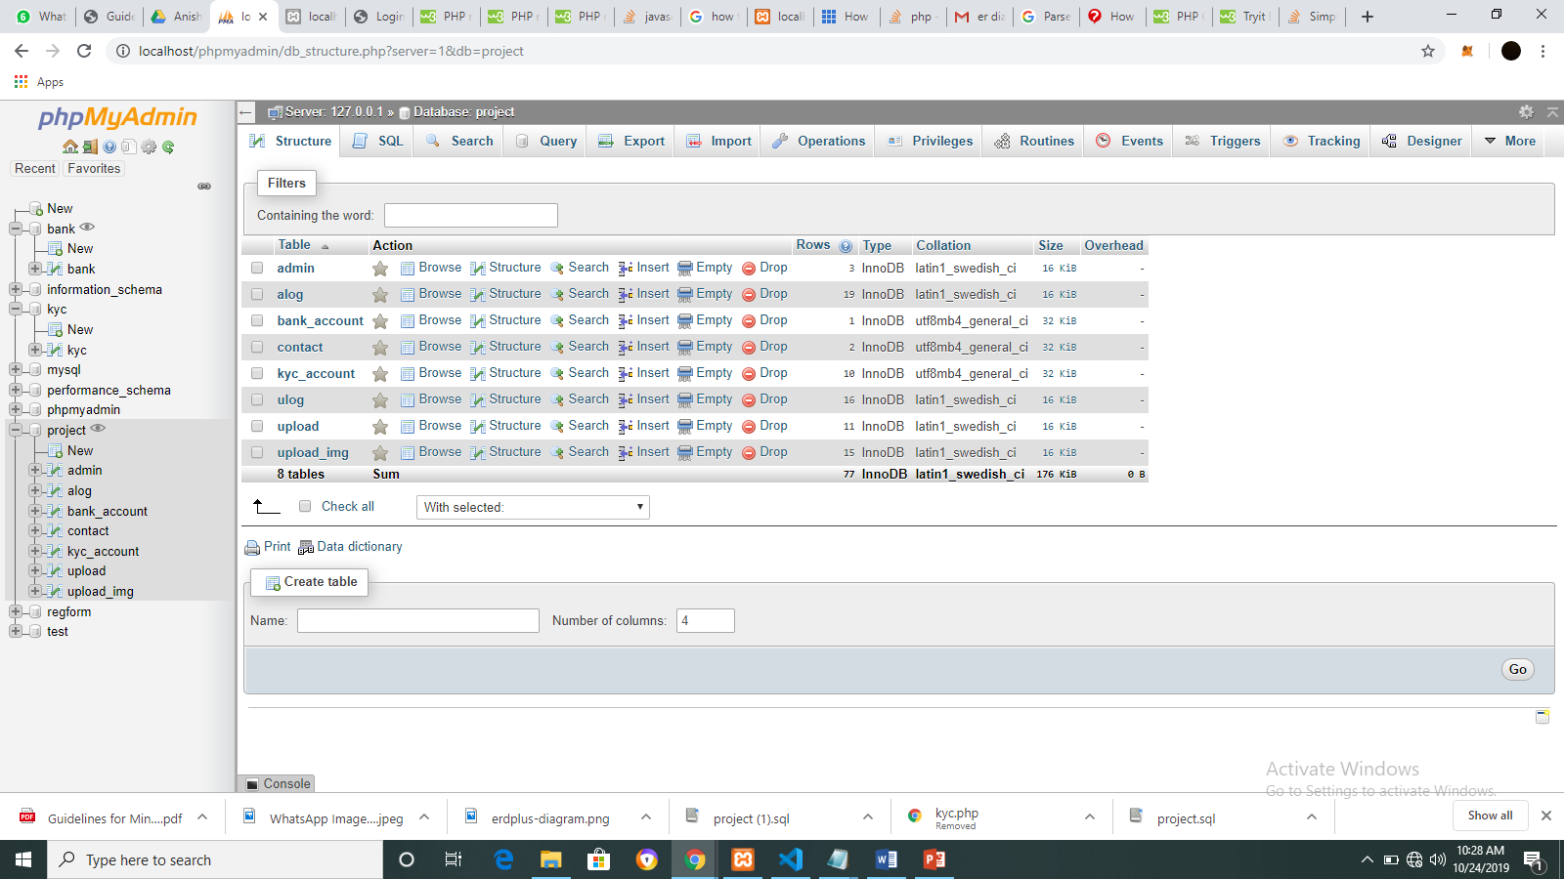

2. Admin table

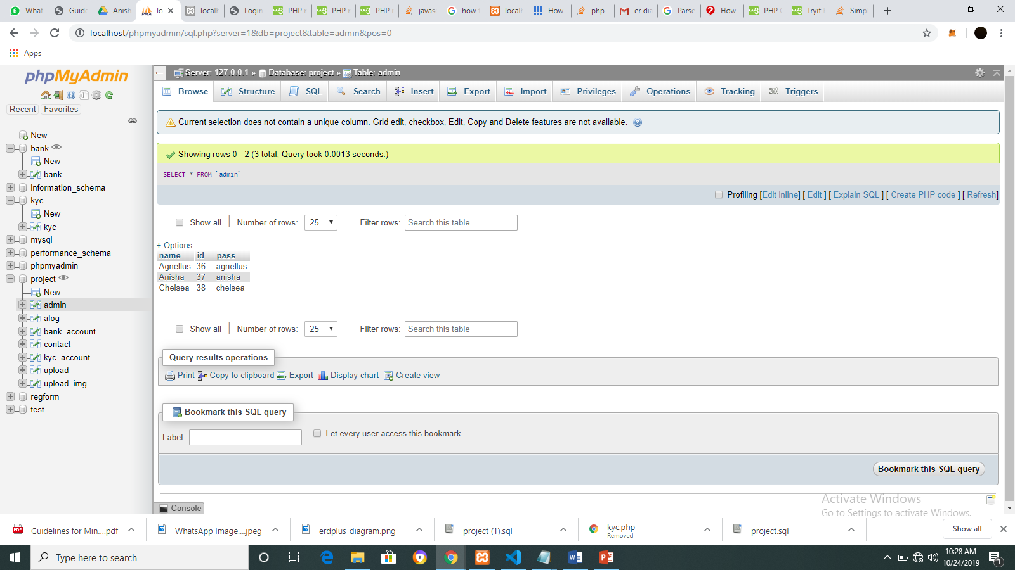

3. Kyc account database

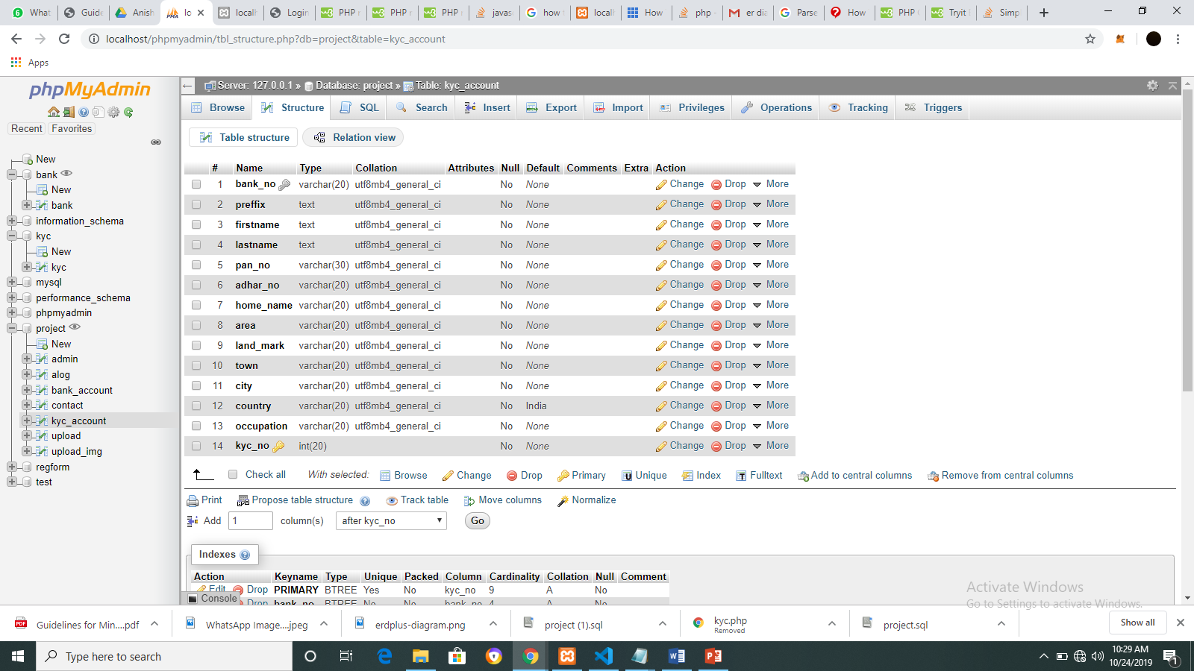

4. Database for property

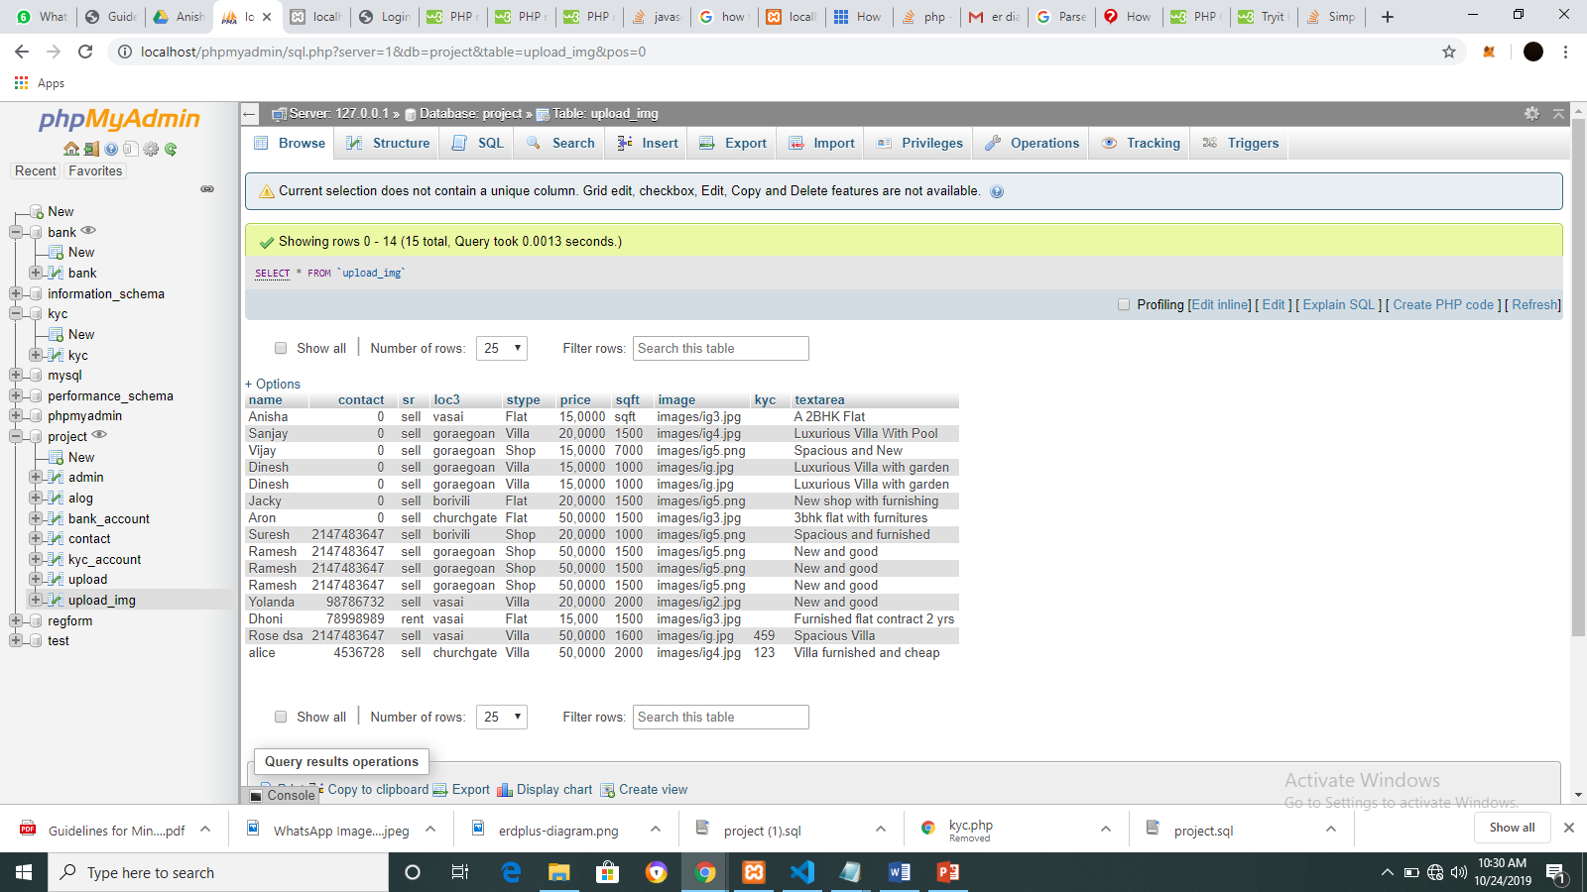

5. Homepage

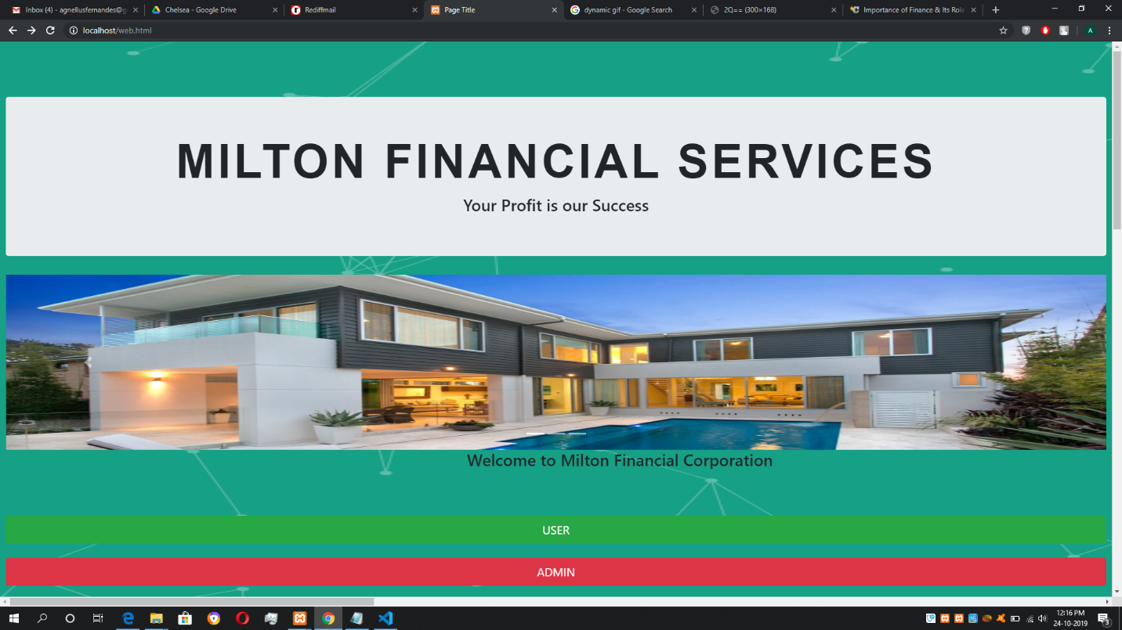

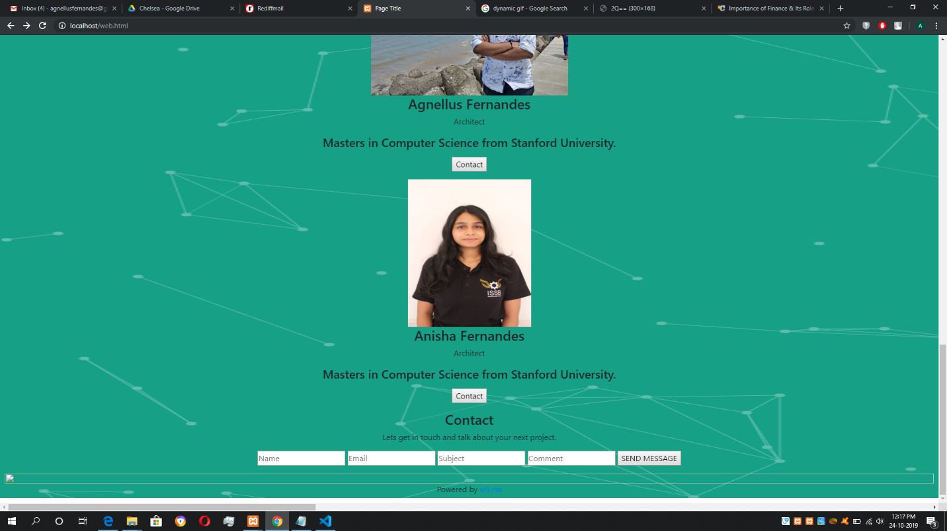

6. User Register

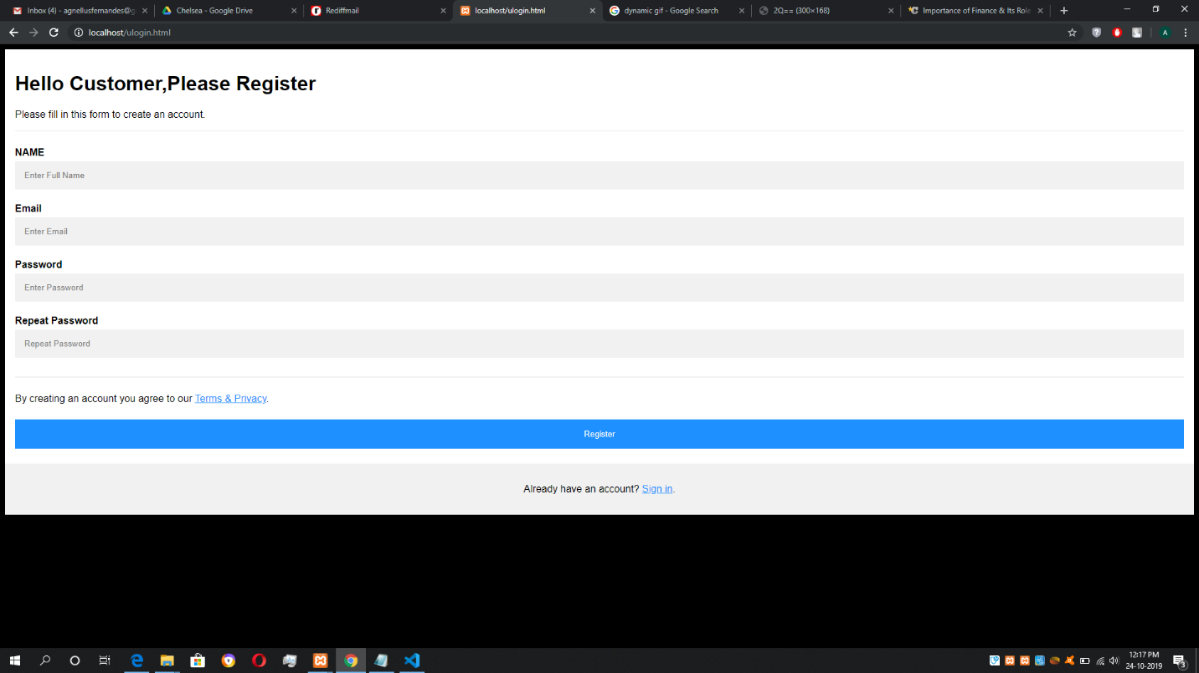

7. Admin Dashboard

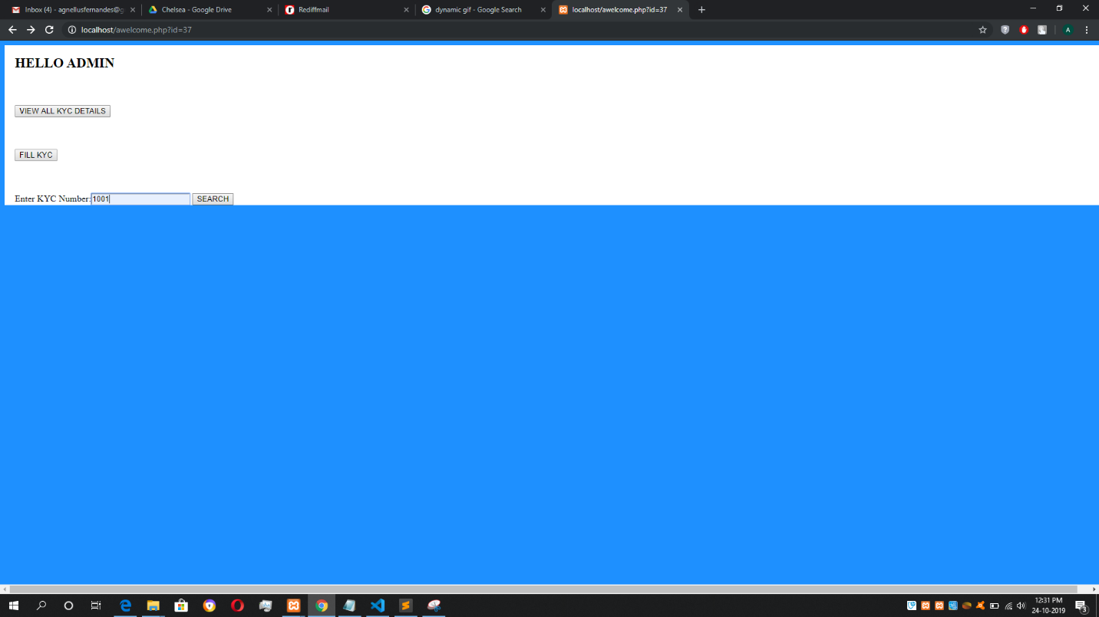

8. User Dashboard

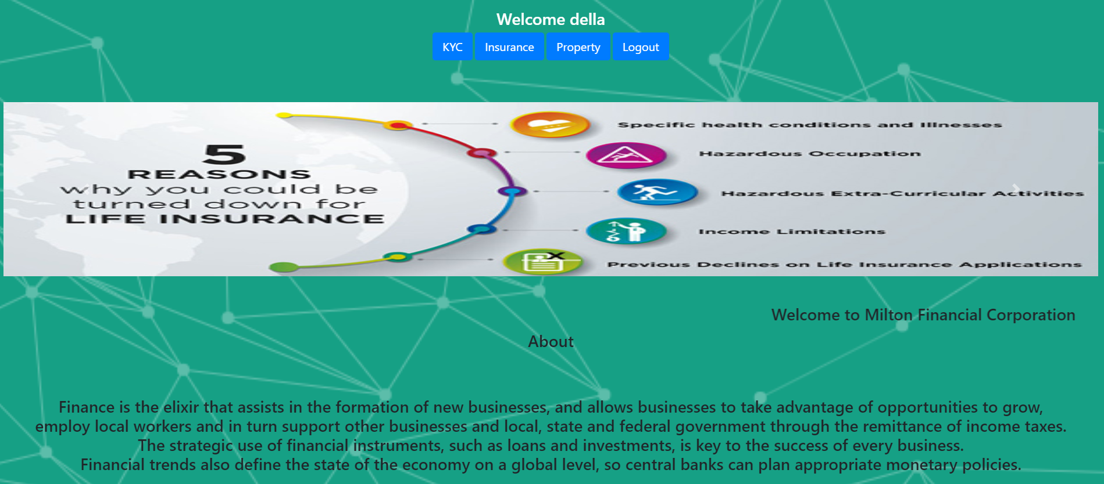

9. KYC

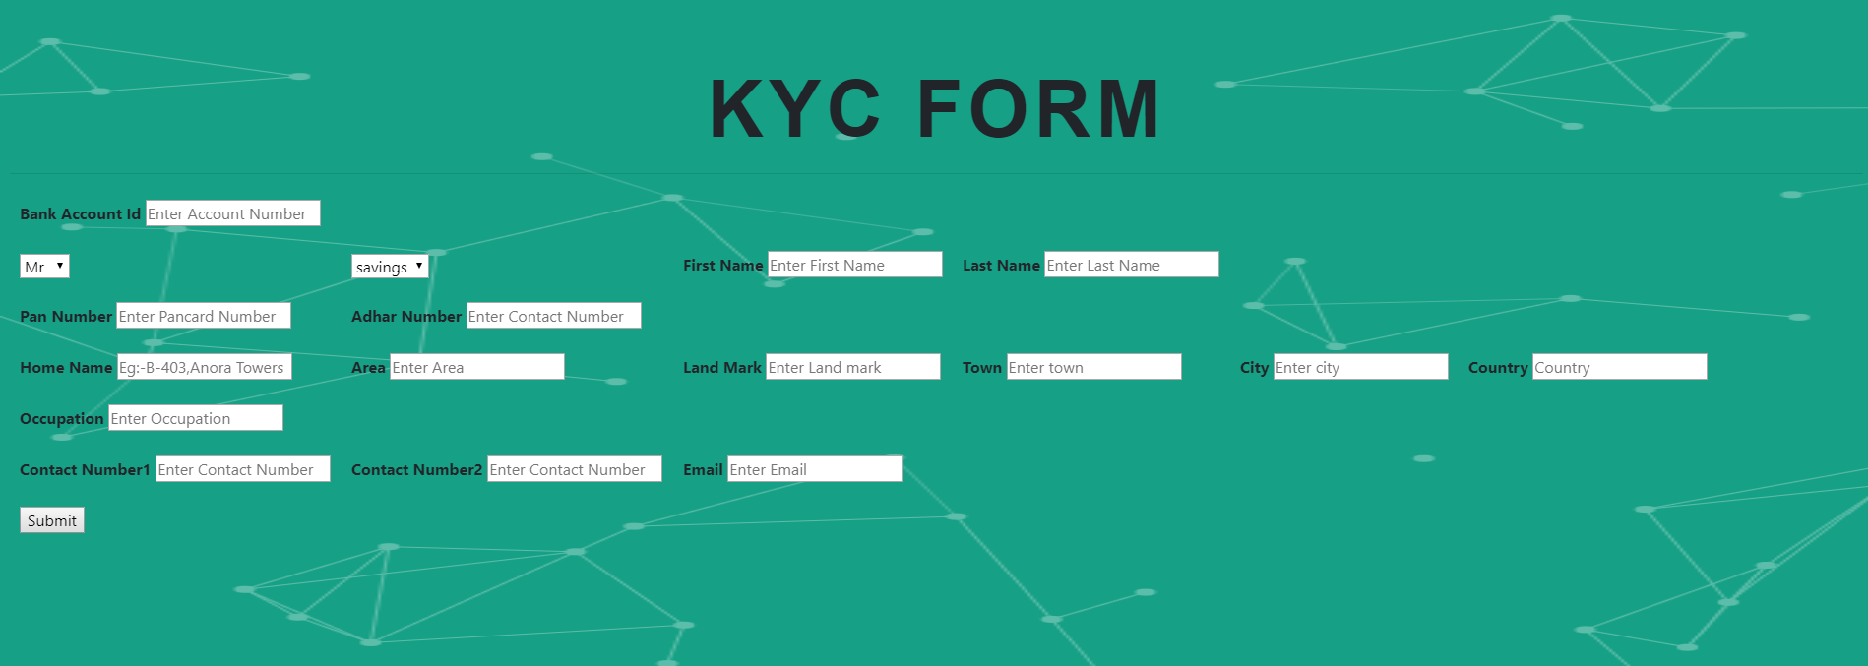

10. Insurance

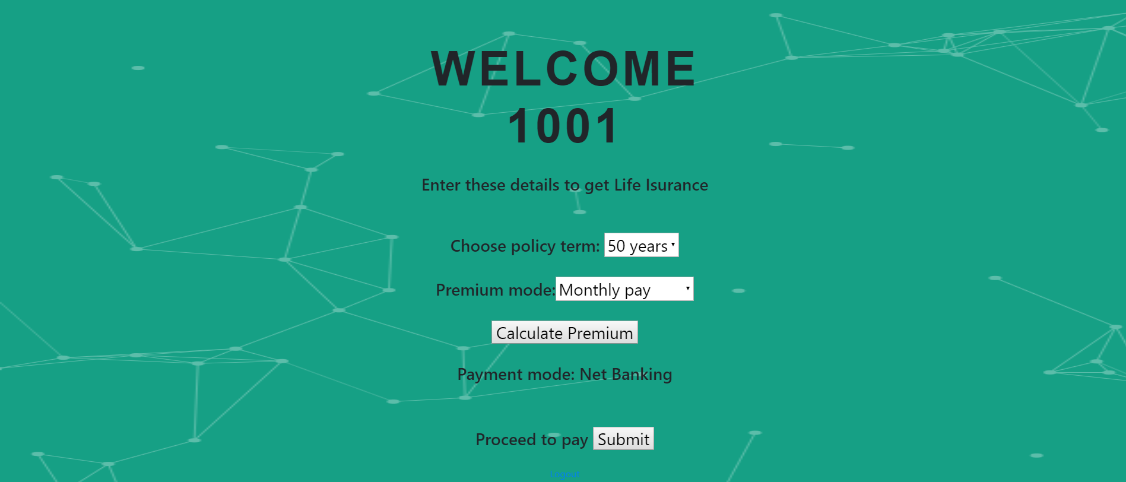

11. Rent

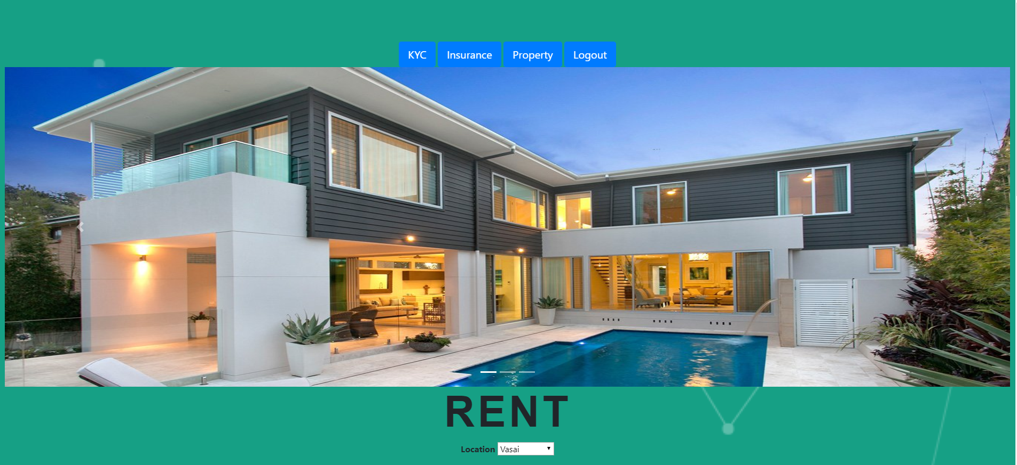

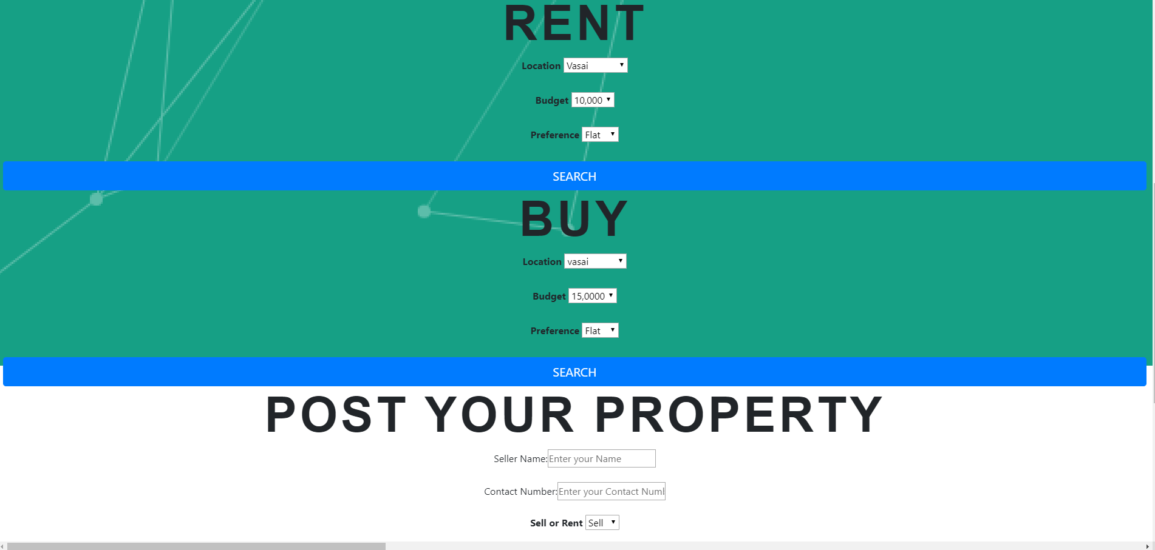

# 7. REFERENCES

[https://www.softwaretestingclass.com](https://www.softwaretestingclass.com/)

[https://www.inflectra.com](https://www.inflectra.com/)

[https://en.wikipedia.org/wiki/functional_requirement](https://en.wikipedia.org/wiki/Functional_requirement)